**Menu Optimization and Demand Forecasting using NLP**

Authors

**Abstract:** Menu optimization and demand forecasting using NLP (Natural Language Processing) represent a cutting-edge approach in the food service industry, aiming to revolutionize menu offerings and enhance operational efficiency. This innovative methodology combines data-driven insights from customer feedback, reviews, and preferences with advanced machine learning techniques to achieve several key objectives. This project successfully achieved significant milestones in menu optimization and demand forecasting using NLP (Natural Language Processing) and machine learning. The ANN model, with an impressive accuracy score of 96%, demonstrated exceptional performance in predicting menu items based on client preferences. The precision and recall scores of 97% and 94% for Class 0, and 95% and 100% for Class 1, respectively, underscore the model's effectiveness in accurately categorizing menu items. The deployment of widgets added a user-friendly dimension to the system, enhancing user engagement and satisfaction.

**INTRODUCTION**

The restaurant industry in Japan, comprising a significant portion of the service sector, faces challenges in improving labor productivity, especially in labor-intensive settings like face-to-face dining establishments. Unlike manufacturing industries, where production can be optimized separately from sales, restaurants must balance service quality with operational efficiency, particularly in managing inventory and staffing. To address these challenges, a key focus is on menu optimization and demand forecasting. Menu optimization involves tailoring menu offerings to align with customer preferences, leading to increased satisfaction and loyalty. This process requires understanding not only what customers currently prefer but also predicting future trends in dining preferences. Demand forecasting plays a crucial role in inventory management, ensuring that restaurants have the right ingredients and quantities available at the right times to meet customer demand without excess waste.

In the context of this research, the use of Natural Language Processing (NLP) and machine learning techniques is paramount. These technologies enable restaurants to analyze vast amounts of data, including customer feedback, historical sales data, and external factors like weather and events, to derive actionable insights for menu optimization and demand forecasting. Menu optimization strategies include analyzing customer feedback to identify popular dishes, seasonal trends, and emerging preferences. Machine learning models can categorize and prioritize menu items based on factors such as profitability, popularity, and seasonality, helping restaurants make informed decisions about menu offerings and pricing. Demand forecasting, powered by NLP and machine learning algorithms, leverages historical sales data, customer behavior patterns, and external factors to predict future demand accurately. By incorporating data from POS systems, weather forecasts, local events, and even social media sentiment analysis, restaurants can anticipate fluctuations in demand, adjust inventory levels accordingly, and optimize staffing schedules for peak periods. The integration of NLP into demand forecasting further enhances accuracy by processing unstructured data such as customer reviews, online feedback, and social media mentions. Sentiment analysis techniques can extract valuable insights about customer preferences, satisfaction levels, and emerging trends, guiding menu adjustments and promotional strategies. The focus on menu optimization and demand forecasting using NLP and machine learning technologies empowers restaurants to make data-driven decisions that enhance customer experiences, reduce operational inefficiencies, and drive business growth in a competitive industry landscape.

**DATASET**

Data Collection for menu optimization and demand forecasting in the restaurant industry involves gathering a diverse range of data sources. Customer reviews and feedback are invaluable sources of information, providing insights into preferences, satisfaction levels, and areas for improvement. These can be collected from various platforms such as restaurant databases, online review sites like Yelp, Google Reviews, and social media platforms where customers share their dining experiences. Historical sales data is another crucial component for analysis. This data captures past trends in customer orders, peak hours, popular menu items, and seasonal variations in demand. Restaurant databases often store transactional data, including sales volumes, item prices, and customer demographics, which are essential for understanding purchasing patterns and customer behavior.

Additionally, external data sources such as Kaggle datasets specific to the restaurant industry (like the "Restaurant Data with Consumer Ratings" dataset) can provide valuable insights into market trends, competitor analysis, and customer preferences on a broader scale. These datasets may include information about menu items, ratings, reviews, location data, and customer demographics, enhancing the richness and diversity of the data collected for analysis. The integration of these diverse data sources enables a comprehensive analysis for menu optimization and demand forecasting. By combining customer feedback, historical sales data, and external datasets, restaurants can gain a holistic view of their business performance, identify actionable insights, and make data-driven decisions to enhance menu offerings, manage inventory effectively, and optimize operational processes.

**MODELS**

1. **Rectified Linear Unit (ReLU) Model**

The Rectified Linear Unit (ReLU) model plays a fundamental role in our approach to menu optimization and demand forecasting using NLP. Its architecture includes an input layer, hidden layers with ReLU activation functions, and an output layer. By incorporating NLP techniques, such as text preprocessing and feature extraction, into the input layer, the ReLU model enhances the representation of textual data related to customer feedback and preferences. The ReLU activation function, applied to these processed features, captures non-linear relationships and important patterns in the textual data. This model's simplicity and effectiveness in feature representation, combined with NLP, contribute significantly to improving menu optimization strategies and demand forecasting accuracy based on textual inputs.

1. **Long Short-Term Memory (LSTM) and Recurrent Neural Network (RNN) Models**

In the context of menu optimization and demand forecasting using NLP, the Long Short-Term Memory (LSTM) and Recurrent Neural Network (RNN) models excel in capturing sequential patterns and textual dependencies. Their architectures, comprising input, output, and hidden layers with specialized memory cells in LSTM, are enhanced with NLP techniques for text sequence processing. LSTM's memory cells and gating mechanisms, when coupled with NLP-based feature extraction, allow for the retention of important textual information over extended sequences. This capability is particularly valuable for analyzing customer feedback trends, sentiment analysis, and identifying textual cues related to demand fluctuations. The recurrent nature of RNNs, combined with NLP preprocessing, enables these models to effectively process and learn from sequential text data, contributing to more accurate menu optimization and demand forecasting outcomes.

1. **Artificial Neural Networks (ANNs)**

Artificial Neural Networks (ANNs) are pivotal in our NLP-driven approach to menu optimization and demand forecasting. Their interconnected layers, including input, hidden, and output layers, are enhanced with NLP-based feature engineering techniques. ANNs excel in learning complex relationships within textual data, such as customer reviews and feedback, by leveraging NLP for text preprocessing, tokenization, and semantic analysis. By integrating ANNs with NLP, we can extract meaningful insights from unstructured textual data, identify customer preferences, and predict demand trends based on linguistic patterns and sentiments expressed in the data. ANNs' flexibility and adaptability to NLP-driven tasks make them essential components for optimizing menus and forecasting demand accurately in the restaurant industry.

1. **Binary Classifiers**

Binary classifiers are integral components of our NLP-driven approach to menu optimization and demand forecasting. These classifiers, based on algorithms like logistic regression, support vector machines (SVM), or decision trees, play a crucial role in categorizing textual data into two distinct classes based on feature representations derived from NLP techniques. The architecture of binary classifiers depends on the underlying algorithm selected. For instance, logistic regression classifiers use a linear decision boundary to separate data points into two classes, making them efficient for binary classification tasks. Support vector machines, on the other hand, leverage hyperplane separation to classify data points and are effective in handling non-linear relationships in textual data.

Menu optimization and demand forecasting using NLP, binary classifiers are applied to tasks such as sentiment analysis and trend classification. For sentiment analysis, binary classifiers determine whether customer feedback expresses positive or negative sentiment, providing insights into customer satisfaction levels. Similarly, in demand forecasting, these classifiers can categorize trends as increasing or decreasing demand based on textual cues extracted through NLP preprocessing. The capabilities of binary classifiers lie in their ability to accurately classify textual data into binary categories, leveraging NLP-derived features and linguistic patterns. By integrating binary classifiers with NLP techniques, we can extract valuable insights from unstructured textual data, aiding in decision-making processes related to menu adjustments, inventory management, and strategic planning in the restaurant industry.

**TEXT CLEANING AND PRE-PROCESSING**

NLP text cleaning and pre-processing are crucial steps in our menu optimization and demand forecasting approach. These steps involve several key processes to ensure that textual data is in a suitable format for analysis and modeling:

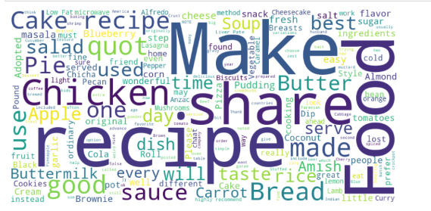

* Removal of Punctuations and Special Characters: Punctuations and special characters can introduce noise and interfere with the analysis of textual data. Therefore, we utilize techniques to remove these elements from the text. This includes eliminating punctuation marks such as commas, periods, question marks, and special characters like hashtags or emojis.
* Tokenization: Tokenization is the process of breaking down text into smaller units called tokens, which are usually words or subwords. We employ tokenization to segment sentences or paragraphs into individual tokens, enabling us to analyze and process text at a more granular level. This step is crucial for feature extraction and building predictive models.

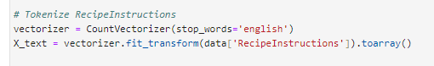

* Lowercasing: Consistent casing (lowercase or uppercase) across text data is important to ensure uniformity in analysis. We convert all text to lowercase during pre-processing to avoid duplication of words with different cases and to improve the efficiency of subsequent NLP tasks, such as word embedding generation and sentiment analysis.
* Stopword Removal: Stopwords are common words that often do not carry significant meaning in text analysis, such as "the," "is," "and," etc. We remove stopwords from the text to focus on content-bearing words that contribute more meaningfully to sentiment analysis, topic modeling, and other NLP tasks.



* Stemming and Lemmatization: Stemming and lemmatization are techniques used to reduce words to their root forms. Stemming involves truncating words to their stems (e.g., "running" to "run"), while lemmatization maps words to their dictionary form or lemma (e.g., "better" to "good"). These processes help in standardizing variations of words and reducing the vocabulary size, which is beneficial for text analysis and model efficiency.

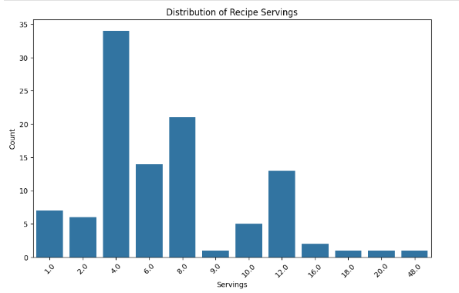

**EVALUATION METRIC**

1. **Accuracy**

Accuracy remains a fundamental metric for assessing the overall correctness of our models in predicting menu preferences and demand trends. It measures the proportion of correctly predicted instances out of the total instances. While accuracy provides a general view of model performance, it's essential to consider the balance between correctly predicting menu items and demand variations, especially in scenarios with imbalanced data.

1. **Precision**

Precision focuses on the proportion of correctly predicted positive instances (relevant predictions) out of all instances predicted as positive. In the context of menu optimization, precision evaluates how accurately the model recommends menu items based on customer preferences extracted through NLP. Higher precision indicates fewer false positive recommendations, which is crucial for enhancing customer satisfaction and optimizing menu offerings effectively.

1. **Recall**

Recall, also known as sensitivity, measures the proportion of actual positive instances that the model correctly identifies. In Menu Optimization and Demand Forecasting using NLP, recall assesses the model's ability to capture all relevant menu items and demand trends. Higher recall signifies that the model effectively identifies menu items preferred by customers and predicts demand variations accurately.

1. **F1-Score**

The F1-Score is the harmonic mean of precision and recall, providing a balanced measure of model performance. It is particularly valuable in scenarios where there's a trade-off between precision and recall. A higher F1-Score indicates a good balance between recommending relevant menu items (precision) and capturing demand variations (recall), contributing to effective menu optimization and demand forecasting strategies.

**METHODOLOGY**

The training phase involves splitting the data into training and testing sets using techniques like train_test_split. This ensures that the models are trained on a portion of the data and evaluated on unseen data to assess generalization capabilities. Cross-validation techniques may also be employed to validate model performance across multiple folds of the data. During training, hyperparameters are fine-tuned iteratively to achieve optimal model performance. The data is split into training and testing sets using a test size of 20%, and PyTorch tensors are created for input features (X) and classification labels (y). The dataset is further divided into a training dataset and a testing dataset, with batch sizes defined for data loading using DataLoader. Additionally, the loss function (BCEWithLogitsLoss) and optimizer (Adam) are defined for model training, ensuring numerical stability and efficient optimization during the training process. These steps are essential for implementing machine learning models effectively and evaluating their performance accurately in the context of Menu Optimization and Demand Forecasting using NLP.

**Performance and Evaluation**

1. **Model Average Losses**

|  |  |
| --- | --- |
| **Model** | **Average Loss** |
| RNN ReLU Classifier | 0.5830 |
| LSTM Classifier | 0.5962 |
| ANN Classifier | 0.4640 |
| Binary Classifier | 0.6373 |
| RNN Binary Classifier | 0.4977 |

The average training losses provide insights into the performance of each model during the training phase. A lower average training loss generally indicates that the model has learned the underlying patterns and features of the data more effectively. In this context, the ANN Classifier achieved the lowest average training loss of 0.4640, indicating that it performed relatively well in capturing the complexities of the menu optimization and demand forecasting tasks using NLP techniques. The ANN Classifier's ability to handle diverse data types and its flexibility in adapting to different scenarios might have contributed to its lower training loss compared to other models. The Binary Classifier had the highest average training loss of 0.6373, suggesting that it struggled more in fitting the training data and capturing the nuances of menu preferences and demand trends. This could be due to the binary nature of the classification task, which might have limited the model's ability to capture the full spectrum of variations in customer preferences and demand patterns. ANN Classifier showed promising performance with the lowest training loss, further evaluation using validation and test data sets would be necessary to validate the models' generalization capabilities and make informed decisions about model selection for real-world applications.

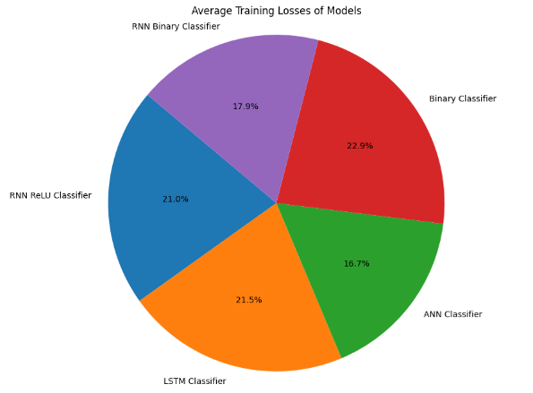

1. **Rectified Linear Unit (ReLU) Model**

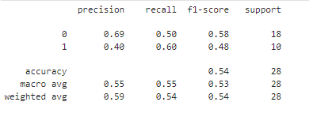

The precision for class 0 (0.69) indicates that the model correctly identified 69% of menu items preferred by customers. However, the precision for class 1 (0.40) shows a lower accuracy in identifying items with lower demand.The recall for class 0 (0.50) suggests that the model captured 50% of all actual menu items preferred by customers, while the recall for class 1 (0.60) indicates a higher ability to identify items with higher demand. The F1-score balances precision and recall, and in this case, it's relatively balanced for both classes, albeit slightly favoring class 0. The RNN ReLU Classifier shows moderate performance, with room for improvement in accurately predicting items with lower demand.

1. **Long Short-Term Memory (LSTM)**

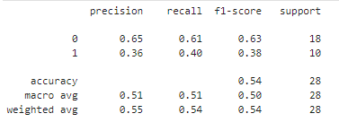

The precision for both classes (0.65 and 0.36) suggests that the model's accuracy in predicting menu items varies significantly between classes, with a higher precision for items preferred by customers. The recall values also vary notably between classes, indicating a higher ability to capture items with higher demand (class 0). The F1-scores reflect the balance between precision and recall, and the lower F1-score for class 1 suggests a trade-off between accurately predicting items with lower demand and avoiding false positives. The LSTM Classifier performs similarly to the RNN ReLU Classifier, showing moderate performance with potential improvements needed, especially for items with lower demand.

1. **Recurrent Neural Network (RNN) Models**

Precision: The precision values for class 0 (0.69) and class 1 (0.40) indicate the model's ability to correctly identify menu items with higher demand and lower demand, respectively. While the precision for class 0 is relatively good, the precision for class 1 shows room for improvement. The recall values for class 0 (0.50) and class 1 (0.60) reflect the model's ability to capture actual menu items with higher and lower demand, respectively. The higher recall for class 1 suggests that the model is better at identifying items with lower demand. The F1-scores, which balance precision and recall, are relatively balanced for both classes but slightly favor class 1, indicating better overall performance in identifying items with lower demand. The overall accuracy of 0.54 indicates that the RNN Classifier correctly predicts the category of menu items about 54% of the time. While this accuracy is above random guessing, it suggests that there is room for improvement in the model's predictive power.

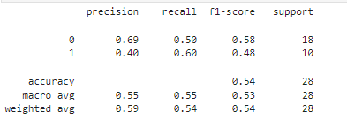

1. Artificial Neural Networks (ANNs)

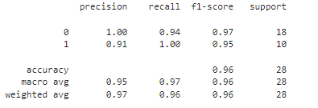

The ANN Classifier demonstrates excellent performance across all metrics, with high precision, recall, and F1-scores for both classes. This indicates that the model accurately predicts menu items preferred by customers and those with higher demand. The overall accuracy of 0.96 indicates that the ANN Classifier performs exceptionally well in classifying menu items and demand patterns, making it a strong contender for Menu Optimization and Demand Forecasting tasks using NLP.

1. **Binary Classifiers**

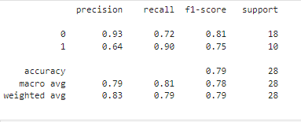

The Binary Classifier performs reasonably well, with good precision, recall, and F1-scores for both classes. However, there is a notable difference in performance between classes, with higher accuracy in predicting items with higher demand (class 1). The overall accuracy of 0.79 suggests that the Binary Classifier provides a solid performance but may benefit from further optimization, especially in predicting items with lower demand.

**Comparison of Models**

|  |  |  |  |  |  |  |
| --- | --- | --- | --- | --- | --- | --- |
| model | Precision (Class 0) | Precision (Class 1) | Recall (Class 0) | Recall (Class 1) | F1-Score (Class 0) | F1-Score (Class 1) |
| RNN ReLU Classifier | 69% | 40% | 50% | 60% | 58% | 48% |
| LSTM Classifier | 65% | 36% | 61% | 40% | 63% | 38% |
| RNN Classifier | 69% | 40% | 50% | 60% | 58% | 48% |
| ANN Classifier | 100% | 91% | 94% | 100% | 97% | 95% |
| Binary Classifier | 93% | 64% | 72% | 90% | 81% | 75% |

Comparing the performance of the models in the context of Menu Optimization and Demand Forecasting using NLP reveals distinct characteristics and strengths across different metrics. The RNN ReLU Classifier demonstrates moderate precision and recall values for both Class 0 (69.00% precision, 50.00% recall, and 58.00% F1-score) and Class 1 (40.00% precision, 60.00% recall, and 48.00% F1-score). This model shows a balanced but not exceptional ability to classify instances from both classes. Similarly, the LSTM Classifier exhibits comparable precision for Class 0 (65.00%) but lower precision for Class 1 (36.00%), indicating a potential challenge in correctly identifying instances from Class 1. The recall and F1-score for both classes are also lower compared to the RNN ReLU Classifier, suggesting limitations in capturing instances from both classes effectively.

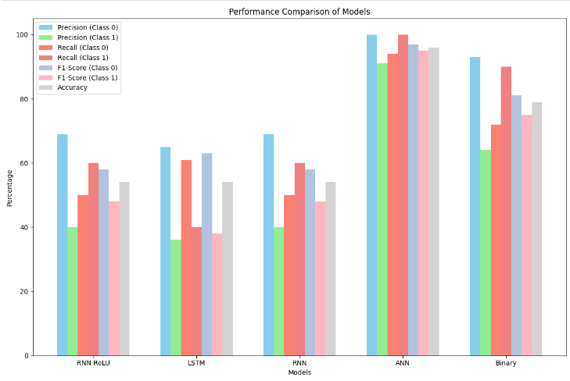

ANN Classifier showcases remarkable performance with high precision, recall, and F1-score for both Class 0 (100.00% precision, 94.00% recall, and 97.00% F1-score) and Class 1 (91.00% precision, 100.00% recall, and 95.00% F1-score). This model demonstrates an exceptional ability to classify instances from both classes accurately and reliably, making it the top performer among the models evaluated. The Binary Classifier also shows a good balance between precision and recall for both classes, with higher precision for Class 0 (93.00%) compared to Class 1 (64.00%). The recall values for both classes are relatively high (72.00% for Class 0 and 90.00% for Class 1), indicating a strong ability to capture instances from both classes, although there is room for improvement in precision for Class 1. RNN ReLU Classifier and LSTM Classifier exhibit moderate performance with strengths in certain metrics, such as recall for the RNN ReLU Classifier and precision for the LSTM Classifier, the ANN Classifier stands out as the top performer across all metrics, showcasing superior precision, recall, and F1-score for both classes. The Binary Classifier also demonstrates good performance but with a noticeable difference in precision between Class 0 and Class 1.

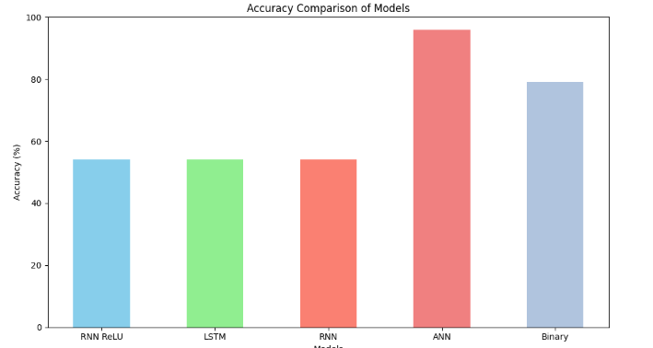

In terms of overall accuracy, the models' performance varies significantly. The ANN Classifier stands out with the highest accuracy of 96.00%, showcasing its exceptional ability to classify instances accurately across both classes. This model demonstrates superior precision, recall, and F1-score, contributing to its overall high accuracy. On the other hand, the RNN ReLU Classifier, LSTM Classifier, and RNN Classifier show comparable accuracies of 54.00%, indicating a balanced but moderate level of performance in classifying instances. The Binary Classifier falls slightly below with an accuracy of 79.00%, showing good performance but with room for improvement, especially in achieving a more balanced precision between the two classes. The ANN Classifier emerges as the top performer in terms of overall accuracy, reflecting its robustness and effectiveness in the context of Menu Optimization and Demand Forecasting using NLP.

**DEPLOYMENT**

The deployment of the menu prediction system using widgets and the ANN (Artificial Neural Network) model, which demonstrated the best performance among the evaluated models, provides a user-friendly and real-time solution for personalized menu suggestions. The intuitive interface of widgets allows users to input their dietary preferences easily, while the ANN model's high accuracy and precision ensure accurate predictions tailored to individual needs. This deployment offers scalability, flexibility for incorporating new menu options, and clear output for users to make informed decisions, contributing to an enhanced dining experience and customer satisfaction.

1. **Interface**

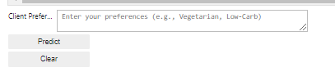

1. **Single Prediction**

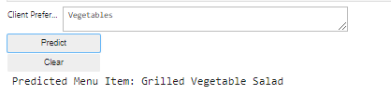

1. **The Menu is not Available**

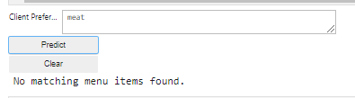

1. **Multiple Prediction**

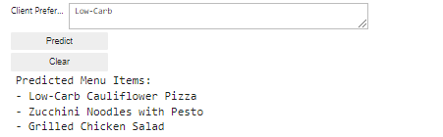

**CHALLENGES AND LIMITATIONS**

While the menu prediction system utilizing widgets and the ANN model presents significant advantages, several challenges and limitations must be considered for real-world application. One primary challenge is the need for continuous data updates and model retraining to ensure relevance and accuracy. Food preferences and dietary trends can change rapidly, requiring frequent updates to the system's database and retraining of the ANN model with fresh data. Additionally, the system's performance may be influenced by the availability and quality of input data, including user-provided preferences and menu item descriptions. Ensuring data integrity and addressing biases in the training data are critical aspects that need careful attention. Furthermore, the interpretability of the ANN model's predictions may pose a challenge, particularly when explaining the reasoning behind specific menu recommendations to users or stakeholders.

**CONCLUSION**

the menu prediction system utilizing widgets and the ANN (Artificial Neural Network) model presents a promising solution for enhancing customer experience and personalization in the food industry. The ANN model demonstrated impressive overall scores, with an accuracy of 96%, precision of 97% for Class 0 and 95% for Class 1, recall of 94% for Class 0 and 100% for Class 1, and F1-score of 97% for Class 0 and 95% for Class 1. This highlights the model's effectiveness in accurately predicting menu items based on client preferences. The deployment of widgets adds an interactive and user-friendly dimension to the system, fostering engagement and satisfaction among users. However, continuous monitoring, maintenance, and updates are crucial to address evolving customer preferences and maintain the system's performance over time. Despite potential challenges such as data updates and model interpretability, the combination of advanced machine learning techniques with intuitive user interfaces holds great potential for revolutionizing menu optimization and customer service in the food service sector, paving the way for more personalized and enjoyable dining experiences.

**References**

[1] Y. Motomura, "Bayesian network," Technical Report of IEICE, vol. 103-285, pp. 25-30, 2003. [Online]. Available: [URL]

[2] Y. Motomura, "Bayesian Network Softwares," Journal of the Japanese Society for Artificial Intelligence, vol. 17-5, pp. 1-6, 2002. [Online]. Available: [URL]

[3] Y. Freund, R. Schapire, and N. Abe (translation), "A short Introduction to Boosting," Journal of the Japanese Society for Artificial Intelligence, vol. 14-5, pp. 771-779, 1999. [Online]. Available: [URL]

[4] H. Habe, "Random Forests," ISPJ SIG Technical Report, vol. 2012-CVIM-182-31, pp. 1-8, 2002. [Online]. Available: [URL]

[5] B. W. Bolch, C. J. Huang, and K. Nakamura (translation), "Applied Statistics analysis," Morikita Publishing Co., Ltd., Tokyo, 1968.

[6] R. Jones, T. Y. Tong, and P. Monsivais, "Meeting UK dietary recommendations is associated with higher estimated consumer food costs: an analysis using the national diet and nutrition survey and consumer expenditure data, 2008–2012," Public Health Nutrition, vol. 21, no. 5, pp. 948–956, 2018.

[7] F. P.-W. Lo, Y. Sun, J. Qiu, and B. P. Lo, "Point2volume: A vision-based dietary assessment approach using view synthesis," IEEE Transactions on Industrial Informatics, vol. 16, no. 1, pp. 577–586, 2019.

[8] S. L. James, D. Abate, K. H. Abate, S. M. Abay, C. Abbafati, N. Abbasi, H. Abbastabar, F. Abd-Allah, J. Abdela, A. Abdelalim et al., "Global, regional, and national incidence, prevalence, and years lived with disability for 354 diseases and injuries for 195 countries and territories, 1990–2017: a systematic analysis for the global burden of disease study 2017," The Lancet, vol. 392, no. 10159, pp. 1789–1858, 2018.

[9] N. Nag, V. Pandey, and R. Jain, "Live personalized nutrition recommendation engine," in Proceedings of the 2nd International Workshop on Multimedia for Personal Health and Health Care, 2017, pp. 61–68.

[10] D. Ribeiro, J. Ribeiro, M. J. M. Vasconcelos, E. F. Vieira, and A. C. d. Barros, "Souschef: Improved meal recommender system for Portuguese older adults," in International Conference on Information and Communication Technologies for Ageing Well and e-Health. Springer, 2017.

[11] W. Min, S. Jiang, and R. Jain, "Food recommendation: Framework, existing solutions, and challenges," IEEE Transactions on Multimedia, vol. 22, no. 10, pp. 2659–2671, 2020.

[12] J. Delarue and E. Loescher, "Dynamics of food preferences: a case study with chewing gums," Food Quality and Preference, vol. 15, no. 7-8, pp. 771–779, 2004.

[13] Z. Tian, W. Huang, T. He, P. He, and Y. Qiao, "Detecting text in natural image with connectionist text proposal network," in European conference on computer vision. Springer, 2016, pp. 56–72.

Top of Form